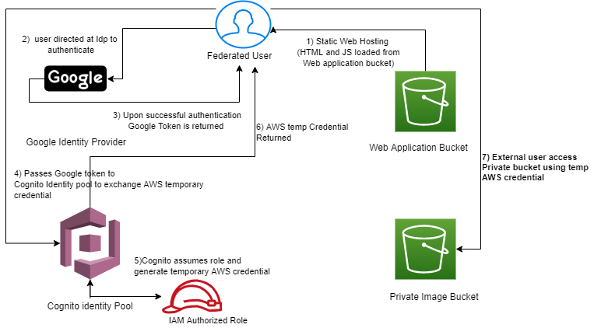

Stepwise process to make federated user to access Private Image bucket

1. Created two buckets (web application bucket and Private Image bucket).
2. Web Application bucket contains HTML file ( points to Google Client ID that direct user to authenticate with Google Identity Provider) . It invokes JS file that calls to Cognito Identity API (pointing Identity pool ID) with Google Access Token as input
3. Cognito assumes authenticated role and generates temporary AWS credentials
4. This temporary credential is used by Federated user to access Private Image bucket

When you click the Sign In button in that HTML page after it gets loaded , a few things happen:-

* You authenticate with the Google IDP
* a Google Access token is returned
* This token is provided as part of the API Call to Cognito
* If successful this returns Temporary AWS credentials
* These are used to list objects in the private bucket
* for all objects, presignedURLs are generated and used to load the images in the browser.